LAND ARC/SOILS/ENV ST 695:
Applications of GIS in Natural Resources

Written report of the group project

Deforestation risk assessment in the state of Pará, Brazil

Colleen Henegan¹, Irene Duch-Latorre², Jake Kruse³, Jordi Francis Clar⁴, Juliana Lira Brandao⁵

¹Nelson Institute for Environmental Studies
² Strier Lab, Department of Anthropology
³ Barak Lab, Department of Soil Science
⁴ Anex Lab, Department of Biological Systems Engineering
⁵ Gibbs Land Use and Environment Lab, Nelson Institute for Environmental Studies

Introduction

Brazil retains the largest area of the Amazon rainforest, that accounts for half of the world’s remaining tropical forests (Bax et al. 2016) and holds the greatest amount of biodiversity on Earth (Aide et al. 2013; Boucher et al. 2013). However, the Brazilian Amazon is severely threatened by deforestation, which has increased dramatically in recent decades (Fearnside 2017a, Fearnside and Barbosa 2004).
Pro-deforestation policies from the 1970’s created incentives for cattle ranching and agriculture in the region (Fearnside 2005, Kaimowitz et al. 2004, Margulis 2004, Moran 1993). As a result, 29,000,000 ha of forest were lost by 1991, and 60,000,000 ha were lost by 2004 – most were cleared for pasture lands (Embrapa and INPE 2014). Conservation efforts began in 1991 that were crucial in reducing the annual deforestation rate by 84% (Arima et al. 2014, Diniz et al. 2015, Nepstad et al. 2014, Mello and Artaxo 2017, Rajão et al. 2017). However, deforestation in Brazilian Amazon suffered a setback after 2013 (Fearnside 2017a, Moutinho et al. 2016). Between 2013 and 2018, the annual deforestation rate was 50% higher than that of 2012 (INPE 2017). This rapid escalation was tied to an increase in international demand for Brazilian beef and soybean. The state of Pará in Brazil is a hotspot for land speculation and cattle expansion and hence one of the largest contributors to deforestation of the Amazon rainforest (Barona et al. 2010; Fearnside 2017b).
It is essential to understand the dynamics of deforestation within Pará, as well as within the Brazilian Amazon, in order to reduce the alarming rates of deforestation. The major drivers of deforestation in Brazil are road construction, mining, population growth, and low household income. Roads provide access to the forest, although rivers also provide “clandestine” roads to deforesters. The risk of deforestation also increases in proximity to hydroelectric dams, which provide energy for mining. Human population growth is positively correlated with deforestation. In addition, household income is negatively correlated with deforestation. Finally, creating and strengthening protected areas is another important step to prevent deforestation, including not only “conservation units” but also “military areas” and “indigenous lands” (Fearnside 2017a).
Therefore, this study aims at developing a simple spatial model that is able to predict the location of future deforestation in Pará. Here we define deforestation as the removal of primary forests (Bax et al. 2016). More specifically, this study has the following aims: (i) to create a Deforestation Risk Map of Pará, (ii) to locate the forests in Pará with higher risk of deforestation, (iii) to identify the driver(s) that best explain(s) deforestation risk in Pará, and (iv) to assess the predictive power of our model by comparing our predictions to the current estimates of deforestation in Pará.
Our study will contribute to a better understanding of the regions that are the most threatened by the drivers of deforestation in Pará and will support the development and implementation of conservation policies in Pará and elsewhere in Brazil.

Materials and Methods
1. Model construction
We followed three steps to build our model and our map: (1) select and quantify the deforestation drivers in Pará, (2) generate raster layers to represent the drivers of deforestation, and (3) generate a composite risk assessment map by conducting a weighted overlay of the raster layers that represent the drivers of deforestation.
1.1. Selection and quantification of the deforestation drivers
First, and following Fearnside (2017a), we classified the deforestation drivers in two categories: (a) accessibility and (b) population. Drivers classified under accessibility included proximity to roads (ACC1), proximity to cities (ACC2), proximity to rivers (ACC3), and proximity to dams (ACC4). Drivers included in the population category were human total population, as a proxy for human population growth (POP1), and average household income (POP2).
We built a partial risk map for each category of drivers, the Accessibility Risk Map, ACC (Eq. 1) and the Population Risk Map, POP (Eq. 2).
$$ACC \left[0-12\right]=ACC1 \left[0-3\right]+ACC2 \left[0-3\right]+ ACC3 \left[0-3\right]+ ACC4 \left[0-3\right] \left(Eq. 1\right)$$
$$POP \left[2-6\right]=POP1 \left[1-3\right]+POP2 \left[1-3\right]+ ACC3 \left[0-3\right]+ ACC4 \left[0-3\right] (Eq. 2)$$
The number is parenthesis indicate the risk range assigned to each of the variables, low ranking indicates low risk of deforestation while high ranks indicate high risk of deforestation.
Second, we built two layers of protected areas, one considering only “conservation units” from the Ministry of the Environment of Brazil (PAR1, Eq. 3) and one including all type of protected areas regardless of governance regime (PAR2, Eq. 4).
$$PAR1 \left[1-2\right]=Con \left[1-2\right]+ACC2 \left[0-3\right]+ ACC3 \left[0-3\right]+ ACC4 \left[0-3\right] \left(Eq. 3\right)$$
$$PAR2 \left[3-6\right]=Con \left[1-2\right]+ Mil \left[1-2\right]+ Ind \left[1-2\right] ACC 4 \left[0-3\right] \left(Eq. 4\right)$$
1.2. Generation of raster layers for the drivers of deforestation
The map layers used for the drivers of deforestation were retrieved from public sources (Table 1). First, all shapefiles were converted to the Global Coordinate System WGS 1984, using the “define projection” tool (Coverage). Second, all the shapefiles were clipped to the contours of Pará (Fig. 1), designated by the shapefile “Pará Municipalities” using the “Clip” tool.
Accessibility Risk Map (ACC)
The Accessibility Risk Map (Fig. 2) was created by drawing buffers at 5, 10, and 20 km around cities, roads, rivers and dams using the “Multiple Ring Buffer” tool (Analysis toolbox). The multiple buffers were converted to raster using the tool “Polygon to Raster” (Conversion), raster values were assigned according to the value of the center of the cell and the cell size was set to 0.05. To ensure that the new raster maps cover the entire study area, the “extent of the environment” settings matched the layer containing information about the municipalities of Pará and the state outline.
Empirical weighting values from 0 to 3 were assigned to the buffer rings using the “Reclassify” tool (Spatial Analyst). The smaller ring, encompassing a 5 km radius around the interest feature (e.g. river, dam and road) was assigned the highest weight or risk of deforestation, 3. Subsequent buffer rings were assigned with a value of 2 for a 10 km radius buffer and 1 for a 20 km radius buffers. Areas outside of the 20 km radius buffers were assigned a weight of zero.
These operations generated four different raster layers (ACC1, ACC 2, ACC3, ACC4) that were combined into the Accessibility Risk Map, using the “Raster Calculator” tool (Map Algebra Toolset) and Eq.1.
Population Risk Map (POP)
The Population Risk Map (Fig. 3) classified the different municipalities of Pará with an empirical weight based on human total population and household income. Values for human total population and household income per municipality were obtained in a tabulated format. Therefore, these values were joined with the map of Pará municipalities using the tool “Join” (Join and Relates). Both layers were converted to raster using the tool “Polygon to Raster”, raster values were assigned according to the value of the center of the cell and the cell size was set to 0.05. Since the original values for human total population and household income were continuous variables, we transformed them into a 3-level categorical variable according to the natural breaks of their density distributions using the “Reclassify” tool.
These produced two risk raster layers (POP1, POP2). For both maps, the highest weight value (3) was associated with the highest value of the variable of interest (for total population) or the lowest vale (for household income). The layers POP1 and POP2 were converted to raster and combined through summation using the “Raster Calculator” tool (Eq. 2).
Protected areas (PAR)
We created a layer of protected areas of Brazil (PAR), considering both “conservation units” (Cons) under federal or state-level agencies and protected “indigenous lands” (Ind) under the National Foundation of the Indian (FUNAI) (Fearnside 2017a). We also included in our analysis “military areas” (Mil) (Fig. 4). Nolte and coworkers (2013) have confirmed that all types of protected areas, regardless of their objective, contribute to prevent deforestation in the Brazilian Amazon regardless of their specific conservation objectives. However, there is no land designation status that guarantees zero deforestation (Nolte et al. 2013). Therefore, after converting all three layers to raster format (“Polygon to Raster” tool), we reclassified them as follows: areas inside any protected area were assigned a value of one, whereas the rest of the areas were assigned a weight of two. Later we combined Cons, Ind, and Mil using the “Raster Calculator” tool (Eq. 3, Eq. 4).
1.3. Generation of the composite map
We generated two Deforestation Risk Maps (RISK1, RISK2) in which each area (cell) was assigned a weight according to the likeliness of deforestation (Fig. 5). We use the “Raster Calculator” tool according to the following equations (Eq. 5, Eq. 6):
$$RISK1 =ACC+POP+PAR1 (Eq. 5)$$
$$RISK2 =ACC+POP+PAR2 (Eq. 6)$$
Finally, we assessed the differences in the risk values displayed by the maps RISK1 and RISK2 using a paired-samples t-test and 50 randomly selected points (“Generate Random Points” tool, Geoprocessing).
Additionally, to assess the predictive power of our Deforestation Risk Map, we compared it with a random forest model that was trained using 500 randomly sampled points.
2. Model validation
To conduct the validation of the deforestation risk map we first converted the PRODES 2017 (INPE 2017) data for Pará to raster format using the “Polygon to Raster” tool. Second, we reclassified the PRODES data to create two binary maps where land covered with forest had a value of 1 while any other land cover was classified as zero (“Reclassify” tool). “Forest 2008” showed the remaining forest in 2008 (forest 2017 + deforestation occurred between 2009-2017), and “Deforestation 09-17” showed the deforestation that occurred between 2009-2017. Third we multiplied “Forest 2008” with RISK1 and RISK2. This step allowed us to show the risk of deforestation only within the forest that remained in 2008.
The next step was to reclassify the deforestation risk maps within the “Forest 2008” map in 100 classes, using the “Reclassify” function. Next, we used the “Summary statistics” to quantify the sum of deforestation in each class between 2009-2017. The table was exported to Excel in order to calculate the percentage of deforestation that occurred over the risk map. The percentage was calculated by organizing the fields of the table in descending order and sorting each class according to the ratio of how many deforestation pixels were found in each class. In the last field, we presented the cumulative ratio over the classes. In the end, a histogram was generated to show the percentage of deforestation that occurred in specific deforestation risk classes (Fig. 6).
The random forest model produced with the training data was used to predict deforestation in 2017 for 1000 randomly sampled locations, and these predictions were validated against the PRODES 2017 data set (Fig. 7).
3. Software and Data
We have conducted geospatial analysis using ArcGIS® Desktop Release 10.4 software by Esri (Esri 2016). We also used R (R Core Team 2017) and Microsoft Excel to run statistical analysis and to validate the map. The packages ‘randomForest’ and ‘raster’ were used in R to perform the “random forest” analysis (Hijamans et al. 2019; Liaw and Wiener 2002).

Results
1. Model construction
1.1. Generation of raster layers for the drivers of deforestation
The Accessibility Risk Map (Fig. 2) indicates that the most at-risk areas are in the cities that are found near the intersections of roads and rivers. Their location indicate that they are likely transportation hubs to facilitate the movement of goods around the state. These high-risk areas for accessibility appear along the Trans-Amazonian Highway in the north-central portion of the state, as well as in in the more densely populated northeastern region. A high-risk area for accessibility can also be seen at the border of Pará and the neighboring states of Maranhão and Tocantins.
The Population Risk Map (Fig. 3) shows that the municipalities that are the most at risk of the population deforestation drivers are the north-central portion of the state. These risk areas are often located near cities in the northern portion of the state, but there are some notable exceptions of municipalities with very low risk in the densely populated northeastern region of Pará. Most low-risk areas are found in the south-central portion of Pará, with medium-risk areas comprising the eastern and western borders.
1.2. Generation of the composite map
The two Deforestation Risk Maps (Fig. 5a, 5b) significantly overlap in areas most at risk of deforestation, but Figure 5a displays a more conservative model for predicting deforestation. The south-central and southwestern municipalities in Pará have the lowest risk of deforestation, with a smaller low-risk area in the northwestern portion of the state. The deforestation risk appears to be more neutralized in Figure 5b, with the addition of indigenous lands and military areas reducing the range of risk values.
The paired-samples t-test between RISK1 and RISK2 (Fig. 5) showed that both maps are equally able to predict deforestation risk, t₍₄₉₎=45.008, N=50, P<0.001.
2. Model validation
In the RISK1 category, 80% of the deforestation that occurred between 2009-2017 happened between the deforestation risk classes of 14.46 and 19.41. For “Risk All – con,” 80% of the deforestation occurred between 2009-2017 occurred between the deforestation risk classes of 10.59 and 15.34 (Fig. 6).
With the random forest model, overall accuracy of the model was 74%, and incorrect classification was 26%. Variable importance was similar for all predictors and went in the following order from most important to least important: distance to roads, total population, household income, conservation areas, distance to dams, and distance to rivers. From the variable importance plot (Fig. 8), distance to rivers was the only variable that did not contribute to the model.

Discussion
We have created a Deforestation Risk Map for the state of Pará, Brazil, using a model that accounts for proximity to roads, rivers, dams and cities, human total population and household income, and protected areas. Overall, our map predicts that deforestation in Pará’s Amazon is on the rise, in particular on Northeast Pará (Fig. 5, Fig. 7), as stated elsewhere for Brazil’s Amazon (Fearnside 2017b). Our map also shows the minimal role of “military areas” and “indigenous lands” in baring deforestation. This finding could be an artifact of our model (where these predictors receive low weight), or could actually reflect the severe encroachment “indigenous lands” are experiencing in Brazil by illegal loggers, gold miners, rural enterprises and infrastructure projects (Begotti and Peres 2019).
We have also identified proximity to roads as the most powerful driver of deforestation in Pará (Fig. 8), which has also been considered the main deforestation driver for Brazil (Fearnside 2017a). Surprisingly, and despite the clear pattern of deforestation near rivers in Pará, proximity to rivers does not explain deforestation in our model. We believe that variable importance might have been obfuscated by the high prevalence of rivers throughout the whole state, such that any point appeared close to several rivers. Indeed, rivers may increase accessibility and profitability of agriculture and ranching, and consequently increase speculative and actual deforestation (Bax et al. 2016; Fearnside 2017a)
Our Deforestation Risk Map was able to capture most of the deforestation that has occurred in Pará after 2008 (Fig. 5, Fig. 6). Based on our validation, the outcomes assessment show that 80% of the deforestation that occurred between 2009-2017 happened in the places we foresee in our model. However, model prediction was lower for protected areas. This implies that they may refrain deforestation from happening in their surroundings.
Finally, the results of this evaluation show that deforestation risk models are an important tool for the prevention of deforestation in the Amazon by accurately indicating the sites at higher risk. Our Deforestation Risk Map may assist policy and decision making agencies such as Pará’s and Brazil’s Regional and National Governments. We recommend focusing direct deforestation control measures on the remaining forests in the municipalities north and east of Pará. We also propose the following measures to contain deforestation should be to limit new infrastructure projects (such as roads or dams), boosting rural livelihoods, and increase law enforcement of protected areas besides designating new protected areas (Begotti and Peres 2019; Fearnside 2017a; Fearnside 2017 b).
Implications for conservation
It is noteworthy, however, that deforestation is a dynamic process associated with economic variables that have not been included in the present modeling (Geist and Lambin 2001). We recommend considering these variables in future studies, but if resources are not available, our simple approach with a limited number of predictors was also efficient at predicting deforestation.
Though the predictors used to construct the random forest model and the risk map can help focus deforestation prevention efforts, it is important to remember that there are already many private and public agencies involved in identifying and stopping deforestation in Brazil. On-the-ground data about the drivers of deforestation and real time deforestation tracking, such as that done by the Global Forest Watch, should take precedence over predicted deforestation. Ideally, both types of information should be continuously incorporated into a cohesive management strategy.
Future directions
We have provided the first approach to model deforestation risk in Pará and elsewhere in Brazil, that should be improved according to the lessons learned here.
First, and given the variable importance plot produced by the random forest model (Fig. 7), we suggest calculations for the risk map should at least follow the order of importance for variables in the plot, if not the weight of each variable. Nevertheless, we acknowledge that distance to rivers probably should have a higher weight based on literature (Bax et al. 2016; Fearnside 2017a; Geist and Lambin 2001) and actual deforestation (INPE 2017). Including only larger rivers in the model might make proximity to rivers a more useful variable.
Second, the predictive power of the calculated risk model used here is about the same as the widely used random forest model. Random forest models are already available in many software packages, such as R Studio, and once trained they can be used with new data. However, this project did not produce a software package that performs the calculations and stores the data, which would inhibit adoption of this risk model. Consequently, we urge to produce a software package for future deforestation risk assessments.
Third, we were not able to include deforestation data from the preceding period in the Deforestation Risk Map. We recommend gaining access to this data in order to improve the projected values according to out model.
Figures and tables
Table 1: Data sets and geospatial layers used for the construction of the Deforestation Risk Map of Pará, with their source and a brief description of their characteristics and properties. Original data contained information about the whole country of Brazil and was clipped to the state of Pará.
Layer Name |  | Source | Description | Use | Data type | Geographic Coordinate System | Datum | Projected Coordinate System
Pará  Municipalities |  | IBGE | Contour of the area of study, Pará, and its municipalities. | Compute household income and total population. | Polygon | GCS | WGS 1984 | South America Alberts Area Conic
Cities |  | IBGE | Cities | Compute the ACC index | Point | GCS | South America 1969 | South America Alberts Area Conic
Rivers |  | IBGE | Main rivers | Compute the ACC index | Line | GCS | South America 1969 | South America Alberts Area Conic
Dams |  | ANEEL | Main Dams | Compute the ACC index | Line | GCS_SIRGAS_2000 | D_SIRGAS_2000 | South America Alberts Area Conic
Roads |  | DNIT | Main roads | Compute the ACC index | Line | GCS_SIRGAS_2000 | D_SIRGAS_2000 | South America Alberts Area Conic
Protected Areas | Conservation units  Indigenous lands  Military areas | MMA | Main protected areas | Create the layer PAR | Polygon | GCS | South America 1969 | South America Alberts Area Conic
PRODES 2009 - 2017 |  | INPE | Land cover/use | Validation | Vector | Land cover | South America Alberts Area Conic | South America Alberts Area Conic
IDH_dadosbrutos |  | AtlasBrasil | Tabulated data referring to socioeconomical characteristics for each municipality in the state of Pará | Obtain average household income per municipality (POP2) | Table | NA | NA | NA
Population_census |  | IBGE | Tabulated data referring to population according to each municipality in the state of Pará | Obtain total population for each municipality (POP1) | Table | NA | NA | NA

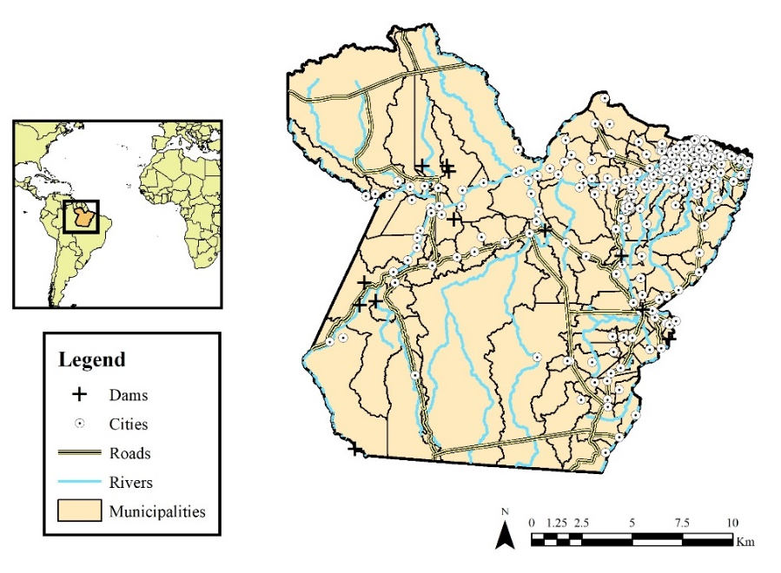
Fig. 1. Map of the study area, the state of Pará in Brazil. Municipalities, as well as dams, cities, roads, and rivers, are displayed in the map.
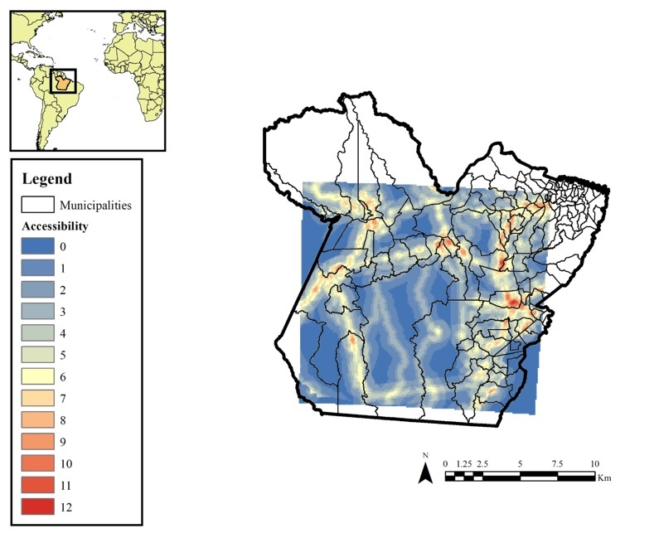
Fig. 2. Accessibility Risk Map (ACC) of the state of Pará, Brazil. Higher values indicate high risk of deforestation, whereas lower values indicate low risk of deforestation.
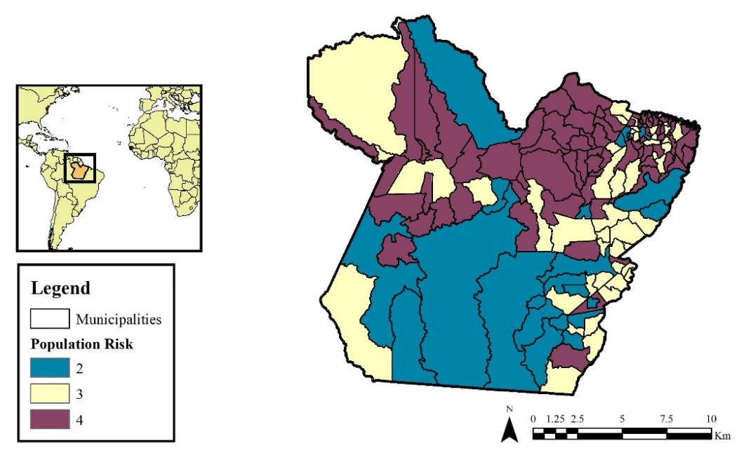
Fig. 3. Population Risk Map (POP) of the state of Pará, Brazil. Higher values indicate high risk of deforestation, whereas lower values indicate low risk of deforestation.
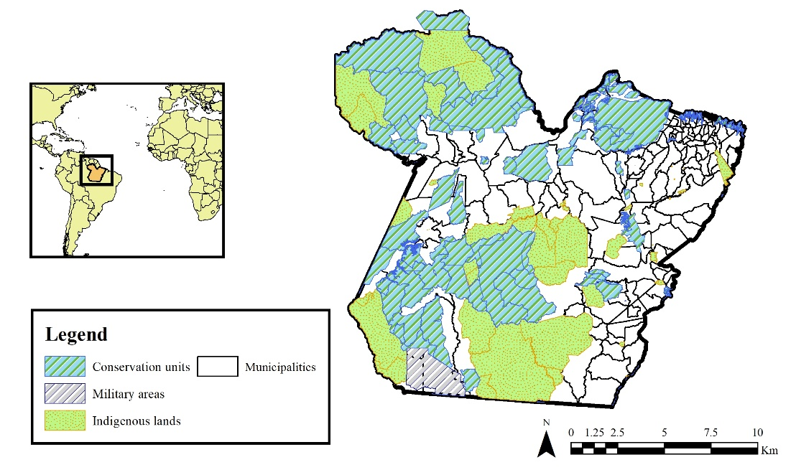
Fig. 4. Protected areas of the state of Pará, Brazil, including conservation units (Cons), military areas (Mil) and indigenous lands (Ind).

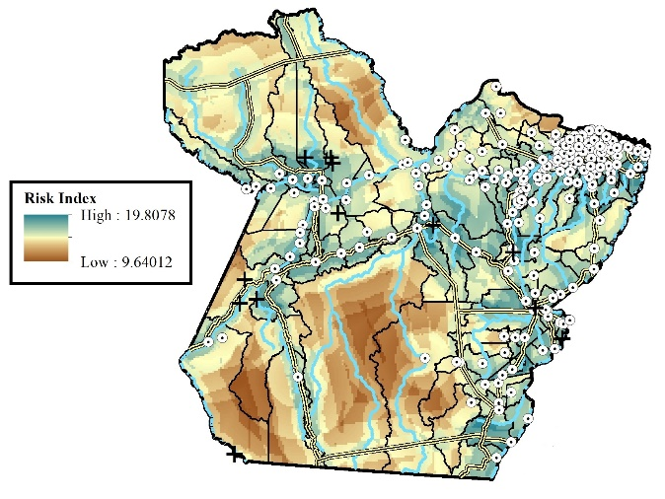
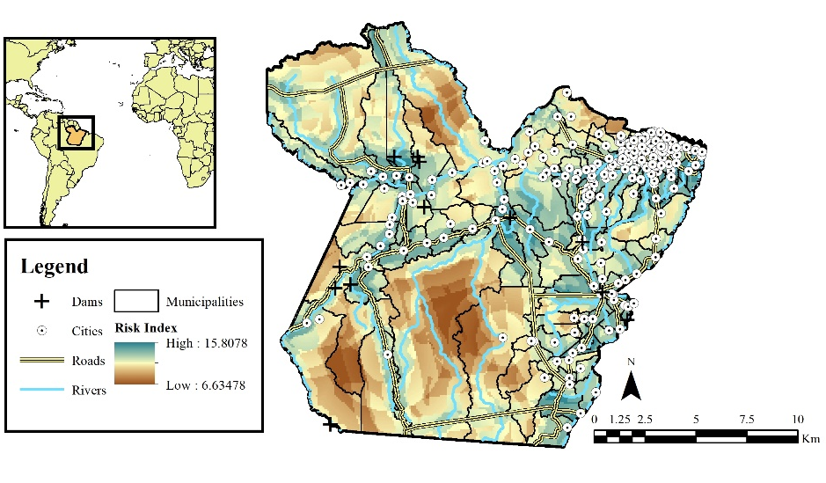
A
B
Fig. 5. Deforestation Risk Map of the state of Pará, Brazil, (a) including only conservation units as protected areas, RISK1 (b) including conservation units, indigenous lands, and military areas as protected areas, RISK2. Higher values indicate high risk of deforestation, whereas lower values indicate low risk of deforestation.
A
B
Fig. 6. Histogram of deforestation between 2009-2017 in the state of Pará, Brazil, (a) for the Deforestation Risk Map RISK1 and (b) for the Deforestation Risk Map RISK 2.
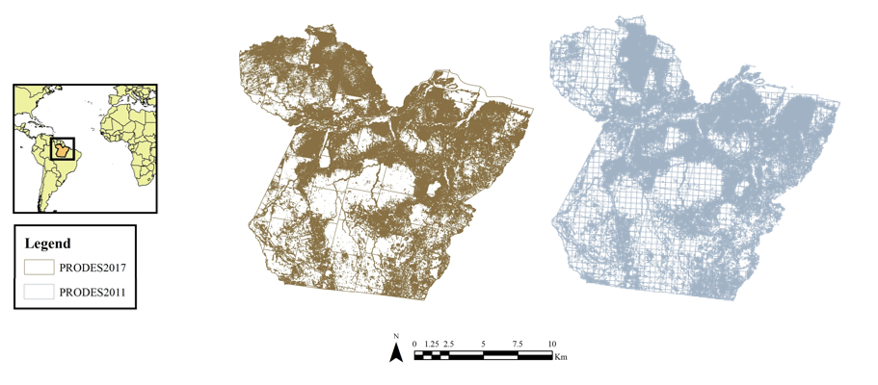
Fig. 7. Annual deforestation in the state of Pará for the years 2017 (left) and 2011 (right), as produced by the monitoring project PRODES (INPE 2017).
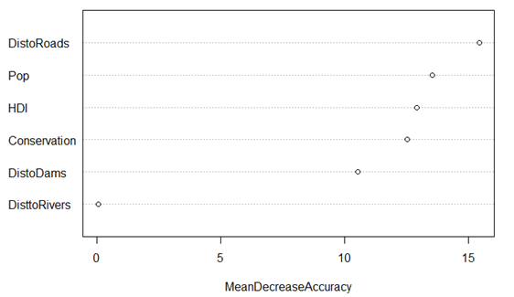
Proximity to roads
Total population
Household income
Protected areas
Proximity to dams
Proximity to rivers
Fig. 8. R-generated variable importance plot for the random forest model. Variables with higher mean decreases in accuracy are more powerful predictors.

References
Aide, T. M., Clark, M. L., Grau, H. R., López‐Carr, D., Levy, M. A., Redo, D., Bonilla‐Moheno, M., Riner, G., Andrade‐Núñez, M. J. and Muñiz, M. (2013). Deforestation and Reforestation of Latin America and the Caribbean (2001–2010). Biotropica, 45, 262-271. doi:10.1111/j.1744-7429.2012.00908.x
Arima, E. Y., Barreto, P., Araújo, E., and Soares-Filho, B. (2014). Public policies can reduce tropical deforestation: Lessons and challenges from Brazil. Land Use Policy, 41, 465–473. doi:10.1016/j.landusepol.2014.06.026
Barona, E., Ramankutty, N., Hyman, G., and Coomes, O. (2010). The role of pasture and soybean in deforestation of the Brazilian Amazon. Environmental Research Letters, 5(2), 024002 (9 pp). doi:10.1088/1748-9326/5/2/024002
Bax, V., Fracesconi, W., and Quintero, M. (2016). Spatial modeling of deforestation processes in the Central Peruvian Amazon. Journal for Nature Conservation, 29, 79-88. doi:10.1016/j.jnc.2015.12.002.
Boucher, D., Roquemore, S., and Fitzhugh, E. (2013). Brazil’s success in reducing deforestation. Tropical Conservation Science, Special Issue, 6(3):426-445. www.tropicalconservationscience.or
Diniz, C., de Almeida Souza, A., Correa Santos, D., Correa Dias, M., Cavalcante Da Luz, N., Vidal de Moraes, D., et al. (2015). DETER-B: The New Amazon Near Real-Time Deforestation Detection System. IEEE Journal of Selected Topics in Applied Earth Observations and Remote Sensing, 8(7), 3619-3628. doi:10.1109/JSTARS.2015.2437075
Embrapa and INPE (2014). Land use maps from the Brazilian Amazon: 1991, 2000, 2004, 2008, 2010, 2012, 2014. TerraClass Project. Available online:www.terraclass.gov.br
ESRI (Environmental Systems Research Institute) (2016). ArcGIS Desktop Release 10.4. Redlands, CA: Environmental Systems Research Institute

Fearnside, P. M. (2005). Deforestation in Brazilian Amazonia: History, Rates, and Consequences. Conservation Biology, 19(3), 680-688.
Fearnside, P. M. (2017a). Deforestation of the Brazilian Amazon. Oxford Research Encyclopedia of Environmental Science. doi:10.1093/acrefore/9780199389414.013.102
Fearnside, P. M. (2017b) Business as Usual: A Resurgence of Deforestation in the Brazilian Amazon. Yale Environment 360, April 18, 2017.
Fearnside, P., and Barbosa, R. (2004). Accelerating deforestation in Brazilian Amazonia: Towards answering open questions. Environmental Conservation, 31(1), 7-10. doi:10.1017/S0376892904001055
Geist, H. J., and Lambin, E. F. (2001). What drives tropical deforestation (Vol. 4). Louvain-La-Neuve, Belgium: LUCC International Project Office.
Hijamans, R., et al (2019). Geographic Data Analysis and Modeling. R News.
Igliori, D. (2008). Deforestation, Growth and Agglomeration Effects: Evidence from Agriculture in the Brazilian Amazon. IDEAS Working Paper Series from RePEc, IDEAS Working Paper Series from RePEc, 2008.
INPE (2017). PRODES. Sistema de Monitoramento do Desmatamento na Amazônia Legal. Ministério do Meio Ambiente, IBAMA, INPE/MCTIC.
Kaimowitz, D., Mertens, B., Wunder, S., and Pacheco, P. (2004). Hamburger connection fuels Amazon desctruction: cattle ranching and deforestation in Brazil’s Amazon. Bangor, Indonesia: Center for International Forestry Research (CIFOR).
Liaw, A., and Wiener, M. (2002). Classification and Regression by random Forest. R News 2(3), 18-22.
Margulis, S. (2004). Causes of deforestation of the Brazilian Amazon. World Bank Working Paper, 22, 1-77.
Mello, N. G. R. de, and Artaxo, P. (2017). Evolução do Plano de Ação para Prevenção e Controle do Desmatamento na Amazônia Legal. Revista do Instituto de Estudos Brasileiros,108. doi: 10.11606/issn.2316-901x.v0i66p108-129
Moran, E. F. (1993). Deforestation and land use in the Brazilian Amazon. Human Ecology, 21, 1–21. doi:10.1007/BF00890069
Moutinho, P., Guerra, R., and Azevedo-Ramos, C. (2016). Achieving zero deforestation in the Brazilian Amazon: What is missing? Elementa: Science of the Anthropocene, 4, 100125. doi:10.12952/journal.elementa.100125
Nepstad, D., McGrath, D., Stickler, C., Alencar, A., Azevedo, A., Swette, B. et al. (2014). Slowing Amazon deforestation through public policy and interventions in beef and soy supply chains. Science, 344(6188), 1118-1123. doi:10.1126/science.1248525
Nolte, N., Agrawal, A., Silvius, K. M., and Soares-Filho, B. S. Governance regime and location influence avoided deforestation success of protected areas in the Brazilian Amazon. Proceedings of the National Academy of Sciences, 110(13), 4956-4961. doi:10.1073/pnas.1214786110
Pfaff, A. (1999). What Drives Deforestation in the Brazilian Amazon?: Evidence from Satellite and Socioeconomic Data. Journal of Environmental Economics and Management, 37(1), 26-43.
Rajão, R., Moutinho, P., and Soares, L. (2017). The Rights and Wrongs of Brazil’s Forest Monitoring Systems. Conservation Letters, 10, 495–496. doi:10.1111/conl.12350
R Core Team (2017). R: A language and environment for statistical computing. Vienna, Austria: R Foundation for Statistical Computing. https://www.R-project.org/.

